

On Saturday January 24th at the Long Island Marriot, the Long Island Metropolitan Lacrosse Foundation held its 40th Annual Hall of Fame Ceremony. The invocation for the night was provided by Class of 1996 and Lacrosse Legend Jim Amen, while the MC for the night was LIMLF First Vice President and Class of 2024 Hall of Famer Paul McDermott.

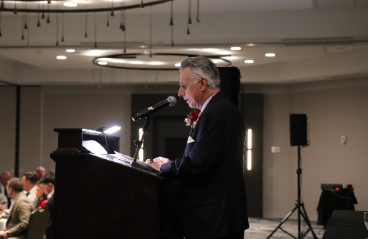
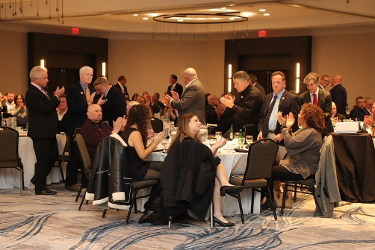

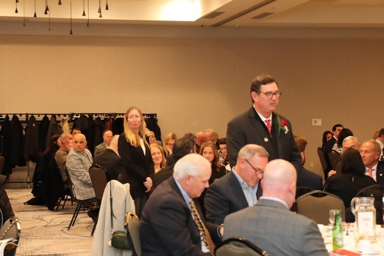
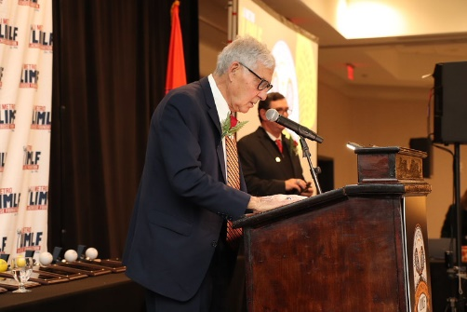
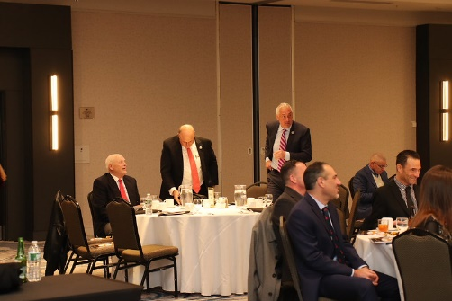

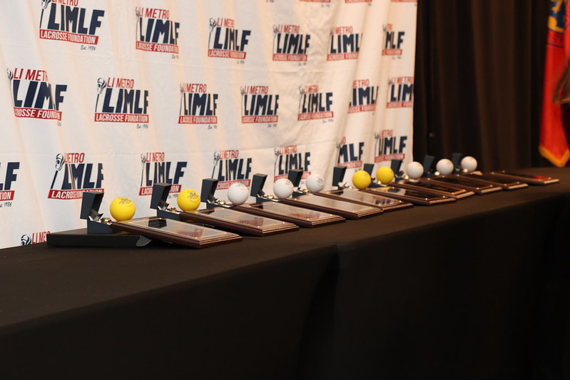

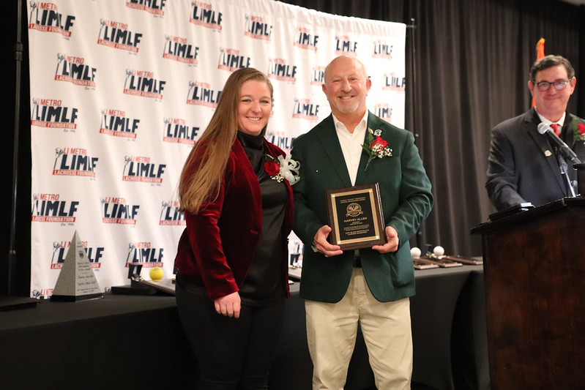
This year’s class is as follows:

The Whitey Henrickson Lifetime Achievement Award- Named for Harold Whitey Henrickson, one of the founders of the LIMLF and it’s first president. This year’s award was presented to Harvey Allen. Harvey began his lacrosse career in 10th grade on the junior varsity team at Elmont High School. He was a midfielder on the Elmont team that captured the school’s first New York State Championship in 1977, defeating Ward Melville. A three-sport athlete, Harvey also competed in football and basketball. He continued his playing career on a lacrosse scholarship at New York Institute of Technology and was a member of the 1980 championship team at Nassau Community College.
Harvey devoted 44 years to coaching lacrosse at eight different schools. He taught at Carle Place Middle School and High School for 32 years, coordinated Nassau County tryouts, and coached in the Empire State Games. He also volunteered at the Shootout for Soldiers, the Never Forget Tournament, USA tryouts, and numerous other lacrosse events. In addition, he worked at the New York Lacrosse Academy and Long Island Lacrosse Camp and coached travel teams for several years. A United States Air Force veteran, Harvey served one tour and attained the rank of Sergeant. He is a member of the American Legion. Harvey has been inducted into both the Carle Place Athletic Hall of Fame and the Elmont Athletic Hall of Fame. He serves as a board member of the LIMLF and is a member of NILCA.
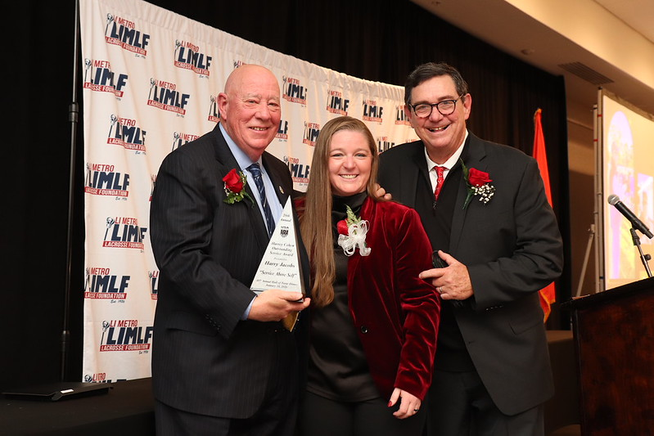

The Harvey Cohen Outstanding LIMLF Service Award- named for the legendary Harvey Cohen who in the 60’s founded Long Island Youth Lacrosse and became synonymous with Long Island youth lacrosse, until this day. Everything to do with lacrosse Youth, Club, USAL National Teams, has Harvey's handprints on it. This year it was presented to Harry Jacobs. Harry’s love for lacrosse started at Hicksville High School in the early 1970’s and his love for the game continues to this day.
With over 50 years in the sport, Harry has worn nearly every hat in lacrosse—player, coach, program leader, LIMLF President, and passionate advocate. Harry was a founding member of the St. Ignatius Youth Lacrosse program in Hicksville in 1976. From 1981 to 1986 Harry was the President of the Long Island Midget Lacrosse League which later became the NCPAL Lacrosse League of which he was also a founding member in 1987 and continues to serve on its Board of Directors. He was a founding member of the Plainview PAL Lacrosse organization in 1997.
Harry also has served two terms as the President of the LIMLF and currently sits on their Executive Board where he is the Chair of the Outreach committee which is committed to providing programs and services that introduce the sport of lacrosse to those unfamiliar with it, reducing financial barriers to participation and supporting the establishment of accessible and self-sustainable lacrosse programs to assure a diverse lacrosse community. Over his many years involved with the game of lacrosse, Harry has been presented with numerous awards acknowledging his dedication, such as the “Homer R. Schwartz” Leadership Award from USA Lacrosse in 2015, “Man of the Year” award in 2012 from both the Nassau County High School Coaches and Lacrosse Officials Associations, the LIMLF “Doc” Schoenbaum award in 2010, recognition by the NCPAL in 2016, and induction into the LIMLF Hall of Fame Class of 2018. Harry has spent the past seven years working as a Regional Director for USA Lacrosse supporting the growth and development of the sport by engaging with members and guiding local lacrosse communities. He recently retired from USAL to focus on volunteering and family. Harry has been married to his wonderful wife Noreen for 45 years and they have two sons, Steven and David, who played lacrosse at Towson University and at Virginia Military Institute, respectively.
Harry now spends his time sharing his passion for lacrosse with his grandbabies. Known for his booming voice, big smile, and even bigger heart, Harry has touched countless lives through his leadership, mentorship, and service. His legacy continues to be felt across the lacrosse community as he leads with action, collaboration, and joy for the game. His work reflects a lifelong commitment to ensuring the game remains accessible, inclusive, and impactful for players of all ages.
This year’s class saw 10 inductees of Coaches, Players and Officials.
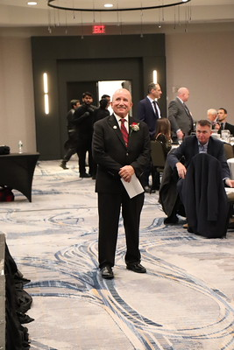
Al Bertolone

A retired Physical Education teacher and coach in the Sachem School District whose coaching career spans several decades. A football, wrestling and men’s lacrosse coach by trade, he credits his daughters Kristyna (softball/field hockey) and Courtney (Lacrosse/field hockey) with his transition to women’s athletics. In the early 2000s he was just another father coaching his daughter in youth lacrosse and watching her play for the LI Yellow Jackets. When the team lost their coaches before the 2002 season he was asked to cover the team for the year. That began a run of 24 of the best years of his life. He is grateful to Carol Rose, Al Rose and Tracy Weiner for the opportunity presented to him and for becoming the lifelong friends they are today. Much of the success he has had is a direct result of this organization and the opportunities given to him and his players over the years.
In 2007 he took a girls lacrosse coaching position at Mt Sinai HS and the rest is history. His dedication to the girls, the program and the community led to his being named Head Coach in 2013 and from that point forward Mount Sinai Girls Lacrosse and excellence were synonymous. He credits Mount Sinai Athletic Director Scott Reh with giving him the opportunity to lead the program. He is also indebted to then MSYL president Pete Van Middelem for his tireless efforts year-round in helping to shape the program. Pete had a vision and Al committed to the process. In 2013 Mount Sinai went 20-0 and captured the school’s 1st ever NY State Championship. In the years that followed Mount Sinai Girls Lacrosse went on to win 3 NY State Championships in a row, 2015, 2015,2016 and 2017. One of only two teams in Suffolk to ever do it. They won the prestigious LIMLF Founders Cup in 2013,2016, 2017 and 2018 as they were ranked the top program in Suffolk County. He amassed 135 wins and only18 losses between 2013-2021and helped place over 68 players into the collegiate ranks. He coached 14 All Americans, 12 Academic All Americans and 2 Long Island players of the year. He was the Suffolk County Coach of the year 2013 and 2018 and was Newsday All Long Island Coach of the year in 2013.
Although he is “retired” he continues to coach at Northport and with the Long Island Yellow Jackets. Throughout his journey, Al’s wife Tricia was a force behind their success. She wasn’t just a supportive spouse she was a vital contributor. She was a calming influence during the toughest of moments. She is and continues to be the coach behind the coach.
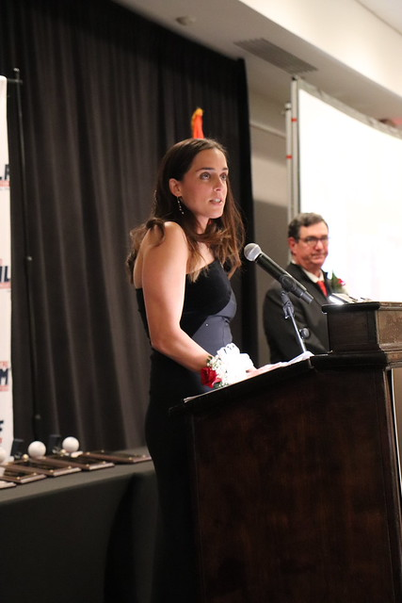
Alyssa Murray Cometti

Alyssa Murray Cometti, a native of West Babylon, N.Y., grew up playing for the Long Island Yellow Jackets and joined the West Babylon High School varsity team in seventh grade. A 2009 High School All-American, Murray set the New York State career assists record (278) in 2010 and was a four-time All-Suffolk County and two-time Newsday All-Long Island selection. At Syracuse University (2011–2014), Murray helped the Orange reach Championship Weekend three times, including two NCAA title game appearances. She was a two-time Tewaaraton Award finalist, a three-time First Team All-American, and the 2013 Big East Attacker of the Year. She graduated with 362 points—second in program history at the time—and became only the second Orange player with 200 goals and 100 assists. As a senior captain, Murray was named Syracuse’s Female Athlete of the Year, earned 2014 ACC Scholar-Athlete honors, and led the NCAA Tournament in scoring.
Murray competed for the U.S. Women’s National Team from 2014–2017, earning a gold medal at the 2017 World Games, and played professionally as the No. 7 overall pick in the inaugural United Women’s Lacrosse League, winning the 2018 UWLX Championship with the Philadelphia Force. Following her collegiate playing career, Murray began coaching at Stony Brook, Michigan, and Yale, later helping expand Iron Horse Lacrosse into a successful girls’ program in Austin, Texas.
She returned to Syracuse in 2021, where she lives with her husband, Luke, and their three children— Mackenzie, Charlie, and Cecilia—and serves as ILWomen Manager for Inside Lacrosse. Alyssa would like to thank her parents, Ray and Lisa, for their endless support, her sister, Corinne, for letting her tag along to the practices that sparked it all, her husband, Luke, for his encouragement and support as her journey in the sport has continued beyond her playing days, and the many coaches, teammates, friends, and family who made the sport so meaningful and special.
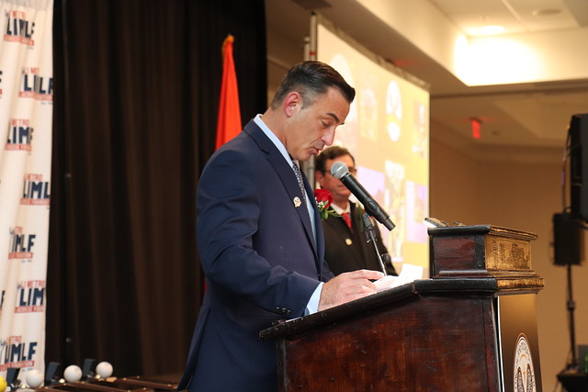
Rob Grella

Rob’s career shines brightly with remarkable talent, unyielding determination, and a steadfast devotion to the sport. He is celebrated as one of the most exciting Attackmen in Division II history, earning the recognition of a two-time First-Team All-American at Adelphi University and playing a pivotal role in several NCAA Championship runs. In 1996, Rob had a season that still ranks among the finest in Division II’s legacy. He topped national scoring charts and received the prestigious NCAA Division II Player of the Year and Attackman of the Year accolades, significantly boosting Adelphi’s reputation as a national contender. He often credits his achievements to the support of his teammates, coaches, and mentors who believed in him. Rob translated that same enthusiasm and skill into his coaching career.
As the head coach of the Adelphi University Women’s Lacrosse program, he led the Panthers to an incredible 22–0 season in 2014, culminating in an NCAA Division II National Championship. This remarkable feat earned him the title of IWLCA National Coach of the Year, alongside recognition from US Lacrosse Magazine as Division II Women’s Coach of the Year, solidifying his place as an esteemed leader in the sport. His influence continued at Dominican University of New York, where he boasts an impressive record of 69–11, clinching three CACC championships and receiving CACC Coach of the Year honors four times. Rob’s excellence in coaching mirrors the same integrity, discipline, and competitive spirit that defined his playing days, shaped by the influential figures who guided him throughout his journey.
Through every phase—athlete, coach, mentor, and leader—Rob has demonstrated unwavering commitment and a profound love for the game. Today, we honor not just his remarkable achievements but also the multitude of athletes he has influenced and the generations he continues to inspire.
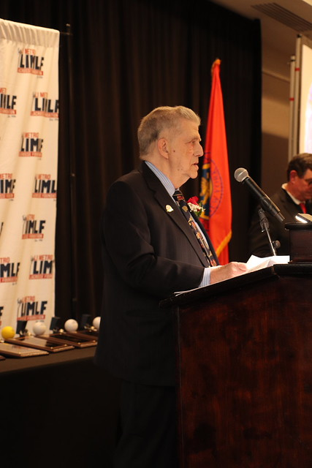
Jim Kaspar

Jim was the captain of the Massapequa HS team in 1963. He then attended Hofstra University and played for legendary coach Howdy Myers. He started his coaching career at Nassau Community College in 1967 as an assistant lacrosse coach in the program’s inaugural season and was an integral part of 8 National Championship teams. He was also an assistant football coach at Nassau from 1968 to 2006. In 1984, he became the head lacrosse coach at MacArthur HS 1984-1989. From 1990 through the 2001 season, he was the head lacrosse coach at Baldwin HS. In 2002 he was an assistant lacrosse coach at Ward Melville HS and then moved on to Northport HS as assistant lacrosse coach from 2003-2005. From 2006 through the 2017 season, Jim was the head lacrosse coach at Long Beach HS.
In the summer of 2014, he was an assistant coach of the New Zealand National Lacrosse team, which finished ninth at the World Lacrosse Championship in Denver, Colorado. From 2018-2021 he was the head lacrosse coach at Locust Valley HS, and in 2019 he led his team to the Conference C championship game. He led every one of his high school teams, previously noncompetitive, to either the semi-final or final high school play offs. He is most proud of this fact and the fact that over 40 of his former players have coached or are now coaching in junior high school, high school or college including the head coaches of two Division 1 programs on Long Island, Hofstra and Stony brook. Jim also ran a successful lacrosse camp, Four Star Lacrosse, and has been a clinician at many clinics during his coaching career. Jim and his wife of 48 years, Susan, reside in Setauket. They have two adult children, Peter and Thea.
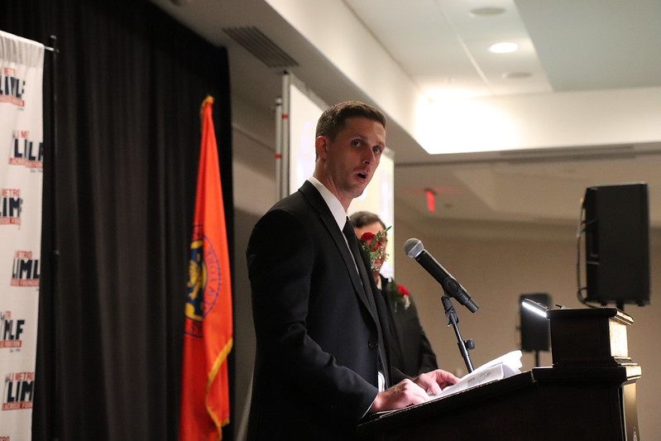
Kieran McArdle

Kieran McArdle’s rise from an under-recruited Long Island high schooler to one of the most respected and consistently dominant attackmen in professional lacrosse is a testament to his relentless work ethic, creativity under pressure, and extraordinary field vision. Overlooked early in his career, he carved his own path through preparation, precision, and an unwavering commitment to his game. Rooted in Long Island’s storied lacrosse culture, McArdle’s journey has unfolded over more than a decade of record-setting achievements, ultimately cementing a career that places him among the enduring figures in the game’s history and one of the sport’s most cerebral, dependable, and unselfish offensive leaders.
A native of Ronkonkoma, New York, McArdle first made his mark at Connetquot High School, where he was a standout attackman known for his vision, deceptive quickness, and field IQ. At Connetquot, he earned All-County and All-Division honors. His senior season established him as a dynamic playmaker with the ability to take over games, laying the foundation for the prolific scoring career that would follow. Though his talent was evident in high school, McArdle entered college as an under-recruited prospect—a reality that fueled his determination and set the stage for a historic career at St. John’s University, where he emerged as one of the most decorated players in program history. Over four seasons, he rewrote the Red Storm record books, earning All-American honors, being named BIG EAST Attack Player of the Year, and securing three First-Team All–BIG EAST selections. He concluded his collegiate career as St. John’s all-time leader in both points and assists, consistently ranking among the nation’s top scorers while playing a central role in elevating the program’s national profile and helping St. John’s compete with established lacrosse powerhouses. More than a decade later, McArdle still holds the program’s career scoring record by a margin that has yet to be challenged. He remains the only player in St. John’s history to surpass 100 goals, 100 assists, and 200 career points. In recognition of his extraordinary impact on the program, McArdle was inducted into the St. John’s Hall of Fame in 2022.
In 2014, McArdle was selected 5th overall in the Major League Lacrosse (MLL) Draft by the Florida Launch, where he immediately established himself as a franchise cornerstone. He delivered a breakout debut season that earned him MLL Rookie of the Year honors, during which he set a rookie scoring benchmark and emerged as one of the league’s most productive offensive players. Since joining the Premier Lacrosse League (PLL) in its inaugural season, McArdle’s veteran presence and consistent production have elevated him among the league’s top performers, earning him recognition as one of the PLL’s most dependable attackmen. When he joined the Waterdogs LC in 2020, his game continued to elevate. During the 2022 season, McArdle led the league in assists and ranked second in total points, serving as a driving force behind the Waterdogs’ run to the PLL Championship victory. In 2017, McArdle brought his game to the National Lacrosse League (NLL), playing for the Toronto Rock, Albany Firewolves, and the New York Riptide over the course of seven professional seasons. His time with the Riptide carried special significance, bringing him back to Nassau Coliseum, where he grew up watching many of the sport’s greats compete, making it a meaningful full-circle moment in his career.
McArdle has also represented the United States of America on the international stage on multiple occasions, bringing home a bronze medal with Team USA at the 2019 World Indoor Lacrosse Championship. In 2023 he again represented Team USA in outdoor competition, earning a gold medal in a championship victory over Team Canada.
McArdle’s impact on the game of lacrosse extends far beyond his own on-field accomplishments. When he is not competing, he dedicates his time to developing the next generation of players as the owner and coach of Lowcountry Rush Lacrosse in South Carolina. He is also the founder of Fun First Lacrosse - a nonprofit organization committed to growing the game of lacrosse by expanding access to the sport and creating a positive introduction to the game. Through his mentorship, instruction, and a genuine love for the sport, McArdle continues to shape the future of lacrosse.

Kelly McPartland
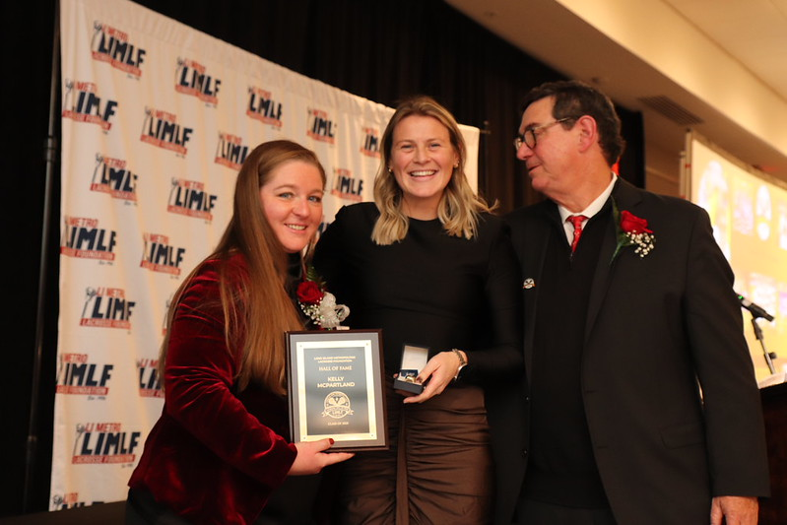

Kelly McPartland, a Farmingdale, N.Y. native, starred as a midfielder at the University of Maryland from 2012-15, where she helped lead the Terrapins to NCAA National Championships in 2014 and 2015. One of the most decorated players in program history, she earned IWLCA First Team All-American, First Team All-ACC, and IWLCA First Team All-Region honors in 2014. She was named to the NCAA All-Tournament Team in 2015, selected to the Tewaaraton Award Watch List in 2014 and 2015, and recognized earlier in her career as an IWLCA Second Team All-Region honoree (2012) and a member of the Synapse Sports All-Rookie Team (2012). A U.S. National Team member from 2014–15, McPartland totaled 61 goals and 94 points during her junior season and served as a team captain as a senior.
Following her collegiate career, McPartland competed professionally in the Women’s Professional Lacrosse League and Athletes Unlimited. She represented the United States Women’s National Team from 2011–15, winning a gold medal at the 2011 FIL U-19 World Championship in Hanover, Germany, and later traveling to Japan in 2018 as part of a WPLL initiative to help grow the game internationally. McPartland transitioned into coaching in 2015 and was named head women’s lacrosse coach at Wagner College in July 2021. In four seasons at the helm, she has posted an overall record of 31–36, including a 26–9 mark in Northeast Conference play.
Most recently, the 2025 Wagner Seahawks earned a share of the NEC regular-season title for just the third time in program history and first in 28 years, finishing 8–1 in conference play and setting a program record with an 88.9 percent NEC winning percentage. Prior to Wagner, McPartland served as an assistant coach and recruiting coordinator at the University of Delaware and spent four seasons at Columbia University, where she helped guide the Lions to their first-ever Ivy League Tournament appearance in 2018. McPartland has also coached with the Long Island Yellow Jackets. McPartland graduated from the University of Maryland with a degree in hearing and speech sciences in 2015.

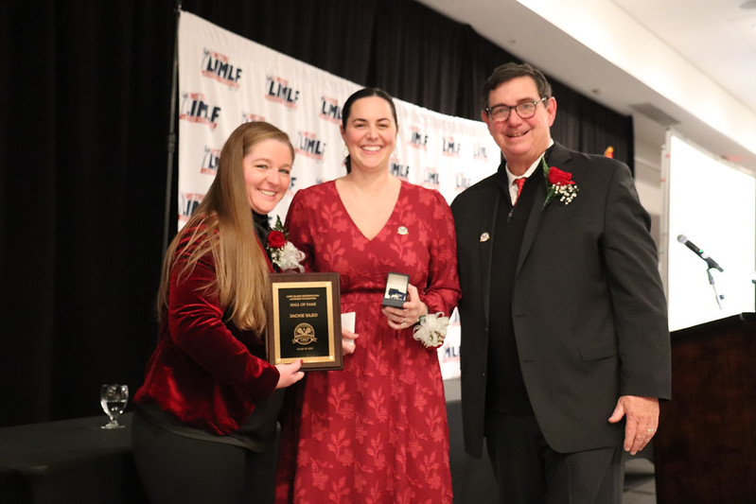
Jackie Sileo

Jackie Sileo played three years of Varsity Lacrosse at Wantagh HS where she earned All-Conference and All-County honors as well as All-American Honorable Mention in her career. Sileo was also named team MVP following her senior season. She led Nassau County in assists and was second on Long Island in 2010. Sileo helped the Warriors to four County Finalist appearances. Sileo also played three years of Varsity Soccer and four years of Varsity Basketball at Wantagh, earning All-Class in soccer and All-Class, All-County and team MVP honors in basketball. Sileo’s four years as an attacker for the LIU Pioneers saw unparalleled levels of success, as she finished her career with more points than any other player in collegiate lacrosse across all divisions. She scored a total of 195 goals and accumulated 369 assists for a total of 564 points.
Although this record was broken last season, Sileo held the record for 11 years. Sileo was a four-time IWLCA First-Team All-North Region selection, along with being named to the IWLCA All-America first-team three times. She was the ECC Player of the Year and IWLCA Attacker of the Year three times as well. The two-time captain was a main catalyst in the program’s national championship victories in 2012 and 2013, as well as a 40-game winning streak which lasted from 2012 through 2014. At the time, Sileo was the only Division II lacrosse player to be named a 2014 Tewaaraton Award semifinalist. She also was one of the nine f inalists for the 2014 NCAA Woman of the Year Award. In addition, Sileo twice received All-Star recognition from the ECAC and was a two-time Honda Athlete of the Year finalist. She was named to the 2013 NCAA Championship All-Tournament Team and was the Most Outstanding Player of the 2012 NCAA Tournament.
Sileo extends her deepest gratitude to her teammates, who equally share this honor; to the coaches who challenged and guided her, and her parents whose support made every milestone possible. She knows that none of her success was achieved alone. Lacrosse has never been an individual sport, and every achievement reflects the collective effort, trust, and dedication of those around her. Sileo accepts this induction with profound appreciation, honoring all who helped shape the player, and the person, she has become.

Sean Smith
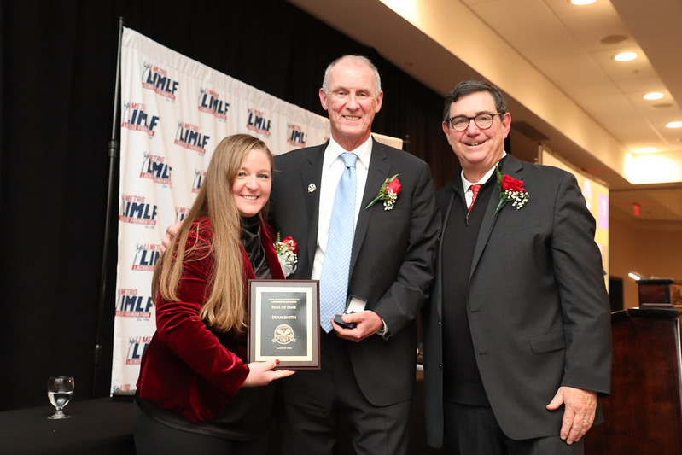

Sean Smith has been involved in the sport of lacrosse for over 40 years, first as an attackman at Levittown Memorial High School. After graduation from Memorial, he attended Nassau Community College. Sean was a member of the 1980 National Junior College Athletic Association National Championship team at Nassau. After his first year at Nassau, he transferred and Smith matriculated at Roanoke College. As a player at Roanoke College, Smith was named a USILA Division III 2nd team All-American in 1982 and First Team All-America in 1983. In addition, Smith was honored as a first team member of the All-Old Dominion Athletic Conference team in 1981,1982 and 1983. Sean was named Conference Player of the year following the 1983 season. Smith concluded his college career as Roanoke’s career leader in goals scored with 145 goals. Sean also ranked third in career scoring with 208 points in forty-three games at the end of his three-year career. Smith still holds the record at Roanoke for points per game at 4.8, a record that has stood since 1983. In 1986 Smith was inducted into the Roanoke College Athletic Hall of Fame.
Following graduation from Roanoke, Smith began his coaching career in 1985 when he served as an assistant coach at Ohio Wesleyan University. In 1986 Sean moved on from Ohio Wesleyan and joined the lacrosse coaching staff at United States Military Academy at West Point where was an assistant coach from 1986 through 1990. In 1990 he returned to Long Island and served as the Head Varsity Lacrosse Coach and Physical Education teacher at Levittown Division Avenue High School. Following the 1997season, Sean moved on to Hofstra University to join John Danowski’s staff as a graduate assistant and obtain his Administration Degree. Following the completion of his course of study Smith was asked to stay on at Hofstra by John Danowski and remained on his staff until 2006. Sean remained on the Hofstra coaching when Danowski moved on, and Seth Tierney took the reins. Smith continued his coaching career at Hofstra through the 2012 season. In 2001, during his time at Hofstra, Sean worked closely and helped develop the winner of the inaugural Tewaaraton Trophy, Doug Shanahan. Under Smith’s tutor ledge, Shanahan was also National Player of the Year and National Midfielder of the Year. Throughout his coaching career at Hofstra Sean has developed 34 All Conference players, five Conference Players and Rookies of the Year, 15 All Americans and 19 North-South All Stars. Two of those All Stars, Doug Shanahan and Brett Moyer, went on to win MVP honors at the North-South All Star game. In 2006 Smith directed Tewaaraton Trophy finalist Chris Unterstein and helped the Pride to a berth in the NCAA Quarterfinals. In his 14 years with the program, Smith also had six players go on the earn USILA Scholar All American honors.
Sean is currently retired after a 35-year career in the Levittown School District. He and his wife Carol now live In Calabash NC. They have three sons JP who lives in Tampa Florida, Brendan who lives in West Islip NY and Conor who lives in West Babylon NY.
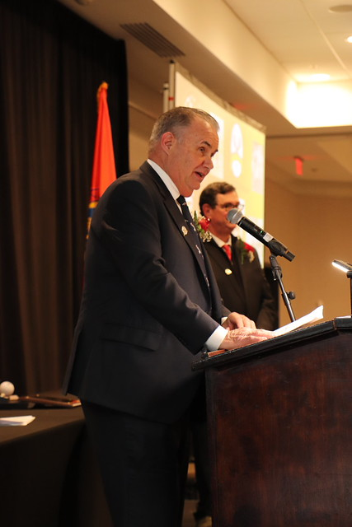
John Sullivan

Sully began his lacrosse career at West Islip High School in 9th grade, making the switch from baseball to lacrosse and following in his brother Joe’s footsteps as a goalie. He earned All-League honors in 1974. The following year, as team captain, Sully was named both All-League and All-County and was voted MVP by the coaches. He also represented Suffolk County in the Suffolk Coaches All-Star Game. A talented multi-sport athlete, Sully earned varsity letters in lacrosse as a goalie, football, and wrestling. In 1975, he was recognized by the West Islip Coaches Association as the school’s Most Outstanding Athlete.
Sully continued his lacrosse career at SUNY Farmingdale under Head Coach Fred Acee. In 1977, Farmingdale captured its first JUCO National Championship, upsetting Nassau Community College 11–8. Sully recorded 27 saves, earned All-Tournament honors, was named MVP of the championship game, and received All-American recognition. In 1978, Sully transferred to Roanoke College, where he played under Head Coach Paul Griffin. That same year, Roanoke won the NCAA Division II-III National Championship, defeating powerhouse Hobart College 14–13. Although Sully played only the second half, he made 18 saves and allowed just two goals. He was named to the All-Tournament Team, earned MVP honors in the championship game, and was again recognized as an All-American in 1979. In his senior year, Sully received the prestigious Paul S. Griffin Award, presented to the senior who best exemplifies dedication and leadership. Sully credits much of his success as a goalie to the late Bob Buhmann of Seaford. In the 1970s, Sully attended the Stroudsburg Lacrosse Camp, founded by his West Islip coach Don Annino. There, Buhmann served as a goalie coach and taught Sully the fundamentals of the position—a mentorship for which Sully remains deeply grateful. This evening, Sully and Sean Smith join fellow Roanoke College alumni John Pirro, Billy Beroza, Bob Rotanz, Richie Graham, Paul Goldsmith, George Powers, and Rocco Guglielmo in celebration.
After graduating from Roanoke College, Sully began his career in law enforcement with the City of Salem, Virginia Police Department. In 1986, after 4½ years of service, he returned to Long Island and joined the Amityville Village Police Department. Over a distinguished 26-year career, Sully earned numerous commendations, departmental awards, and four life-saving awards. In January 2009, he was promoted to Sergeant and retired in 2012 after a career marked by dedication and excellence. Sully is married to his wife, Maureen, and they reside in Amityville.
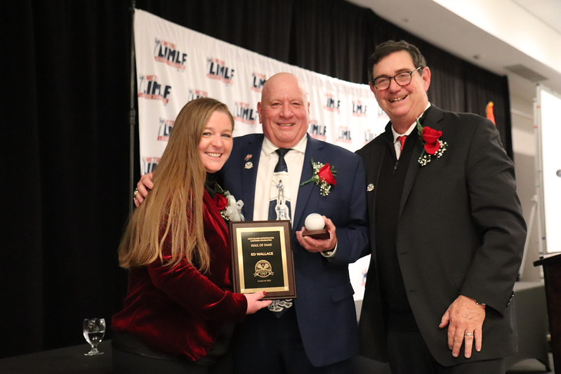
Ed Wallace

Ed graduated from WT Clarke High School in 1976. He Captained the Football and Wrestling teams, and was 2-time Captain of the Lacrosse Team. He was All-League in both Football and Lacrosse and played in both Nassau County All Star games. He was class Vice-President and was presented a Citizenship Award from Congressmen John Wydler. He went on to Hofstra University where he played both Football and Lacrosse. Again, he Captained the Football team and was a 2-time Captain of the Lacrosse Team, and a 4-year starter. His Senior year he was 2nd team All-American, played in the North/South game, and the Superstar game; the Club Allstars vs the College Allstars. Ed played what would now be called a long stick middle, LSM. He was on the wing for every faceoff and played the backer in Hofstra’s zone defense. After graduating from Hofstra in 1980, Ed played for the Long Island Lacrosse Club, again as a LSM, where they won 2 National Club Championships. In 1982 he was invited to the tryouts for the USA Team. He was on the 1st team from Long Island to go to the Vail Tournament.
Ed married his wife Elfi in 1985. He has 2 children, Kristie and Eddie, and 2 grandchildren, Bryson and Charlotte. In 2005 Ed decided that the best way to give back to the sports that gave him so much, was to become a referee. He became a Football, Lacrosse, and Field Hockey Official. He officiates High School in all 3 sports and College Lacrosse. He has been presented with numerous awards for his High School Officiating. Ed is presently the Chairmen of the Officials Coordinating Council, representing all of the High School Officials, Boys and Girls, in Nassau County.
The Long Island Metropolitan Lacrosse Foundation would like to express our genuine appreciation of your support of the Hall of Fame. Thank you for all the Hall of Famers that came to support their new inductees. We would like to extend our deepest gratitude to the incredible Hall of Fame committee, Chaired by Billy Rebman, and its dedicated members, Yvette Seeley, Paul McDermott, John Cuiffo, Harry Jacobs, Howie Borkin, Tommy Susko, Corinne Savino, Joseph Baccarella, Jonathan Laico, Al Hodish, Joe Kovar, Toni Hernen, Melissa D’Angelo, Ed Wallace, Trisha Dean, Kim Miller, Morgan Molinari and Carol O’Sullivanfor who worked tirelessly on the event and selecting this year class of inductees.

